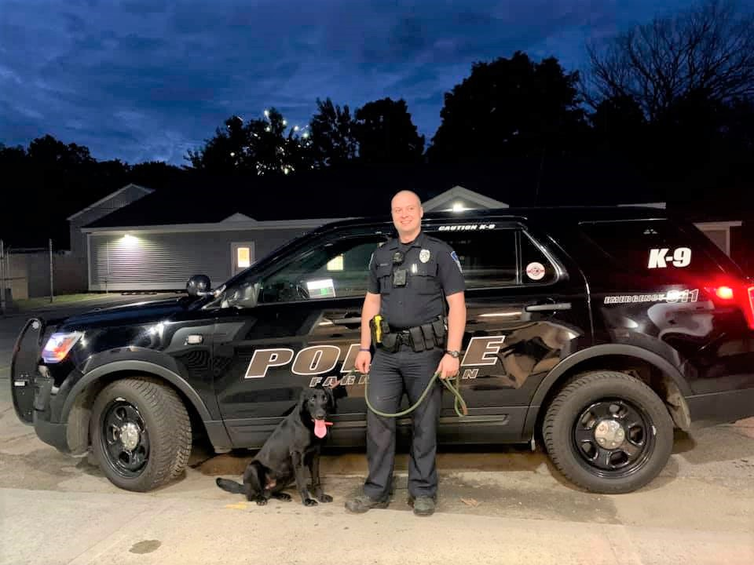Officer Ethan Boyd and K9 Hook  Applicants  Requirements:  - U.S. Citizenship.  - High school diploma or G.E.D.  - 21 years of age or 20 years old with 60 college credits.  - Valid driver’s license.  - Completion of MCJA Phase I and Phase II.  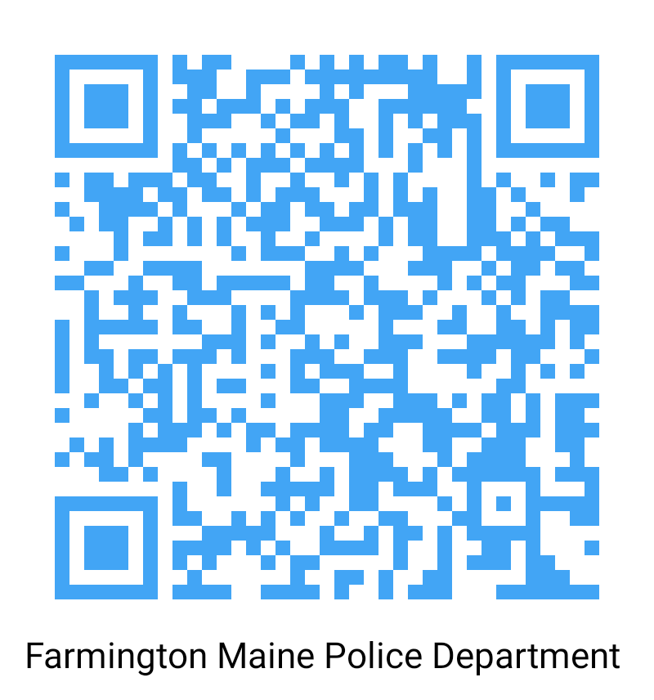  - Meet background, medical, psychological, and physical requirements specific to the department.  SCAN ME FOR MORE INFORMATION  For more information regarding completion of MCJA requirements please visit https://www.maine.gov/dps/mcja/ |  |  | Chief’s  Message  On behalf of the  Town of Farmington  and the Farmington  Police Department,  thank you for  considering Police  employment here. We are  committed to hiring and  retaining those candidates that demonstrate the highest levels of integrity, self-motivation, and desire to serve their communities.  We offer a competitive salary and benefits package with options to meet your needs. We benefit from excellent department facilities and equipment. We offer the best in community, including quality schools for families of all ages. Tuition reimbursement offerings can help you move forward with your own educational goals.  Most of all, our department offers a high quality of life in and out of work. Our area offers the very best in outdoor activities. Several of Maine’s best ski areas, an abundance of hunting fishing, hiking and more are right out your doorstep. Did you know that Franklin County boasts the 3rd lowest cost of living but is closest to the state’s population centers?  Farmington is an exceptional place to live, work, and raise a family. I encourage you to reach out to learn more.  Contact Us  Address: 116 Franklin Avenue,  Farmington, Maine 04938  Non- Emergency: (207) 778-6311  Emergency: 911  Web: https://www.farmington-maine.org/police-dept-home  Find us on Facebook: https://www.facebook.com/FPDME |  |  | Farmington Police Department  - “To create a feeling of safety for the people within the Town of Farmington”.  Mission Statement

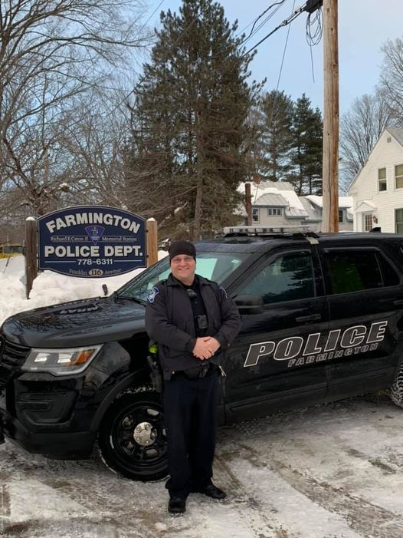  Officer Ryan Rosie  Sign on Bonus  Blue Pins  - Eligible for a total bonus of up to $8000 with no MCJA buyout. Tiered for $2000 at start, $2000 after year 1 and $4000 at year 3.  - Eligible for a total bonus of up to $4000 for officers with a MCJA buyout. Tiered for $1000 at start, $1000 at year 1 and $2000 at year 3.  Green Pins  - Select applicants may be approved for a sign on bonus for up to $2000 based on experience and/or education.  For further information regarding a sign on bonus, please contact the department. |  |  | A GREAT PLACE TO WORK  The Farmington Police Department is a well-respected, proactive, professional police department dedicated to providing community-oriented police services in Western Central Maine. We are looking for highly motivated individuals to serve our jurisdiction.  The Farmington Police Department is an equal opportunity employer.  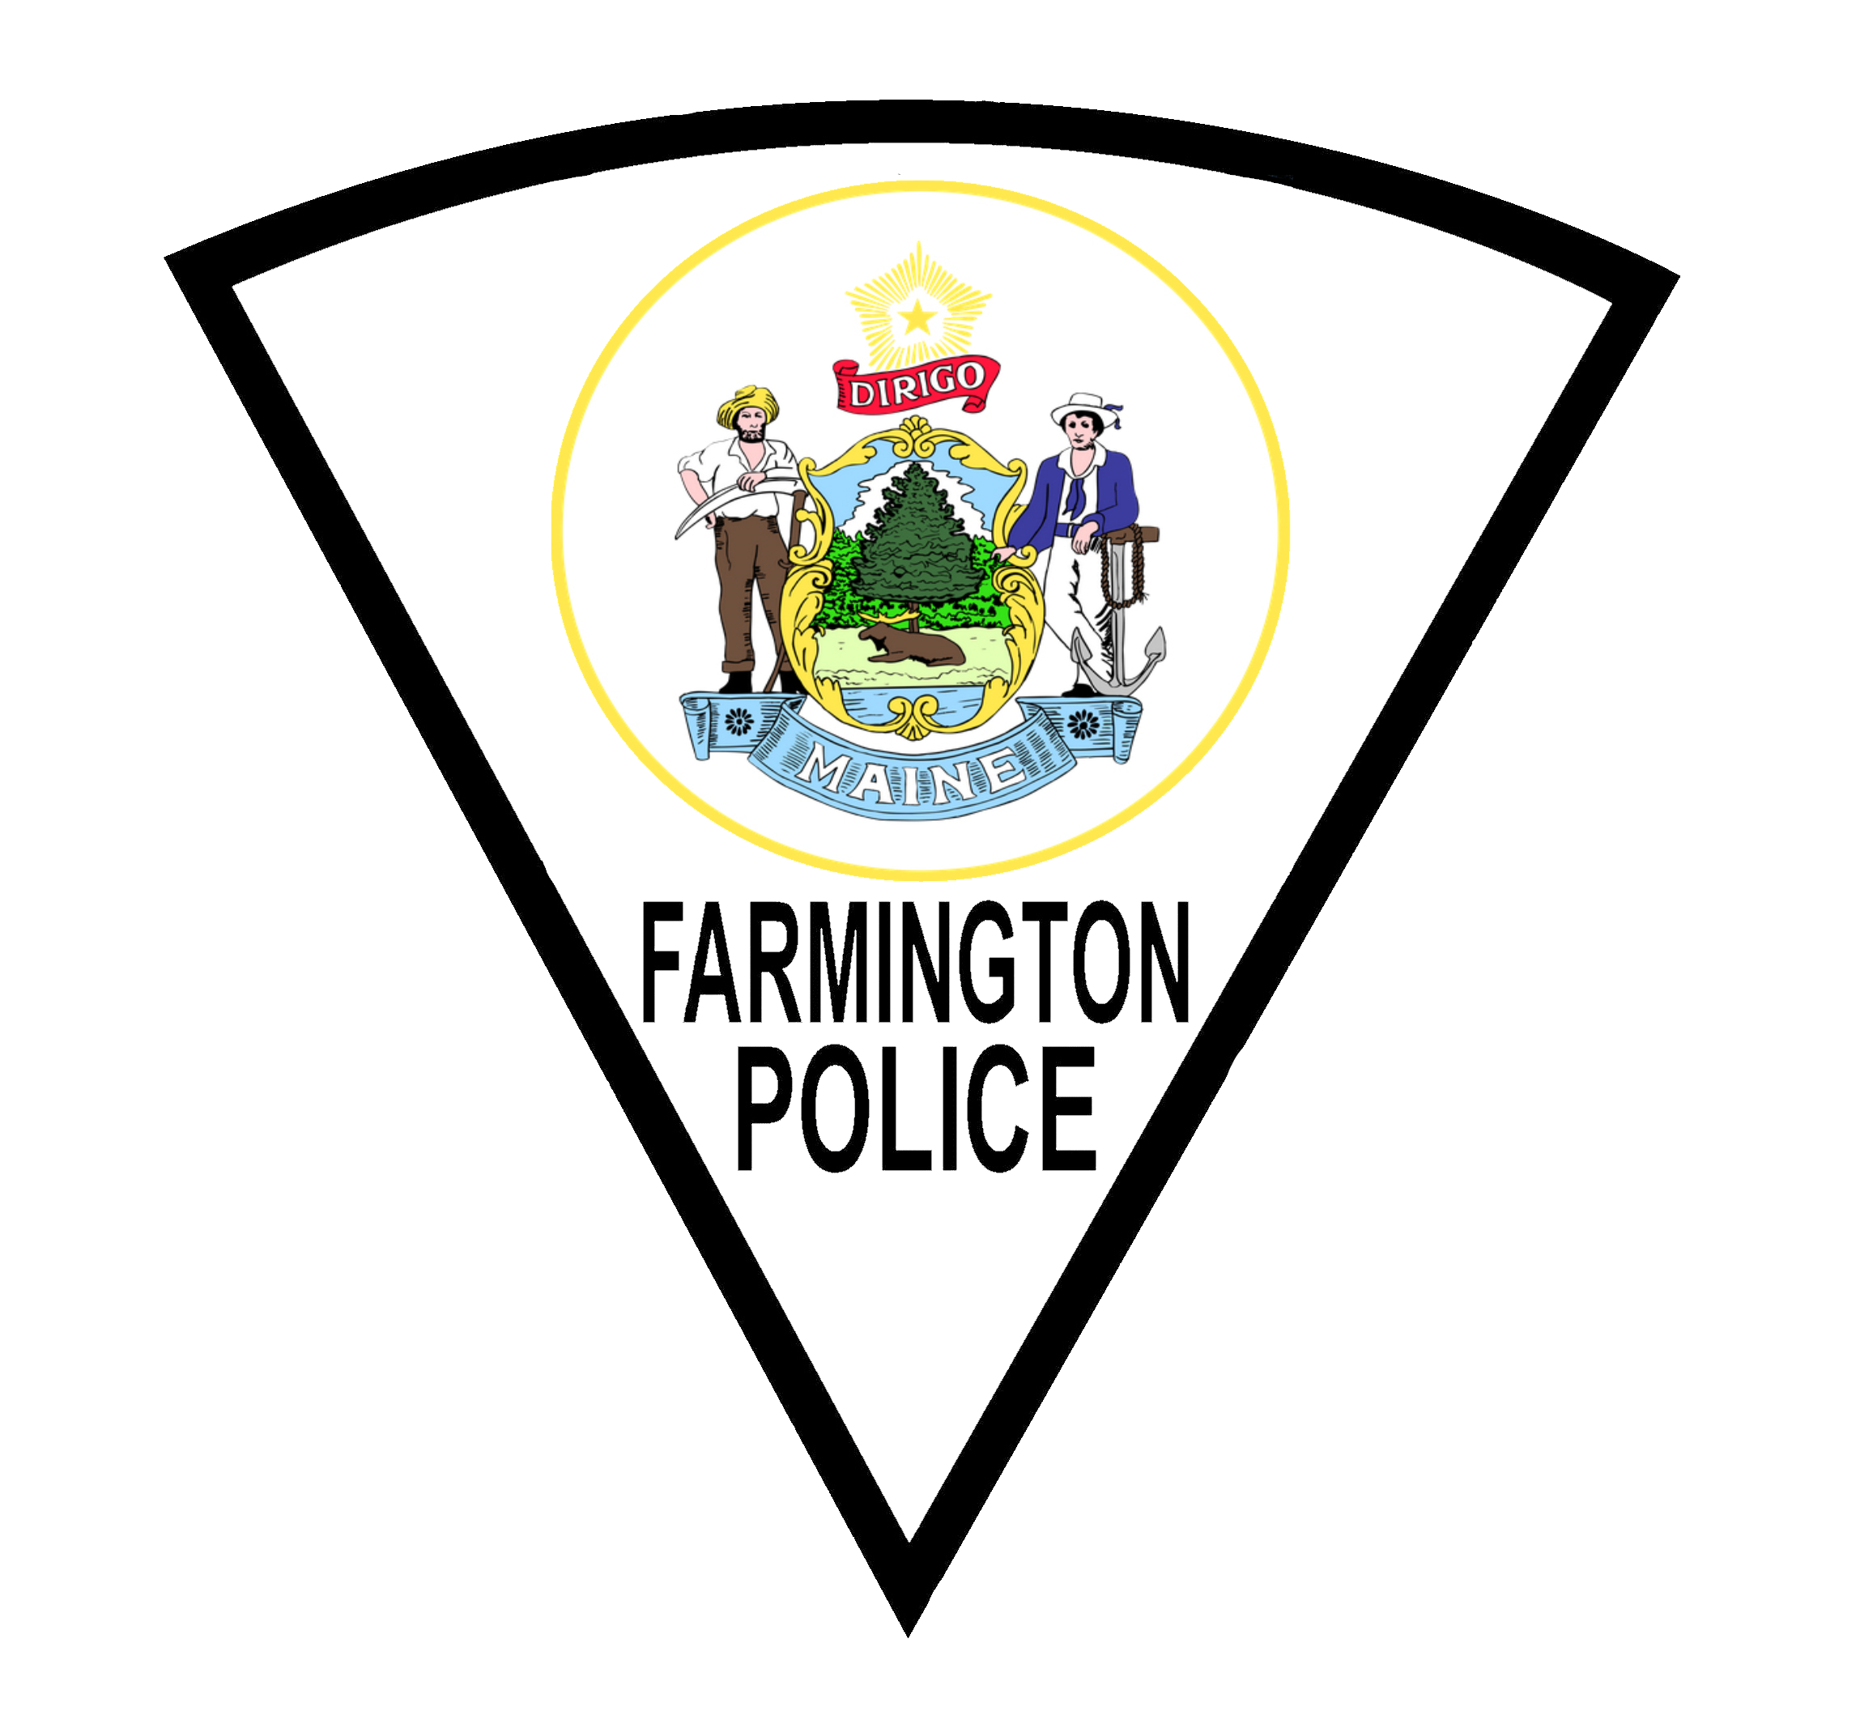  “Super officers! Thank you for keeping us safe”. Resident Facebook Post 2020  A GREAT PLACE TO LIVE  Farmington is the largest town in Franklin County. Outdoor recreation is abundant with Maine Huts & Trails, snowmobiling and hiking areas including the Whistle Stop Trail as well as nearby State Parks. The Sandy River runs through the heart of Farmington providing excellent fishing and tubing trips. |  |  | 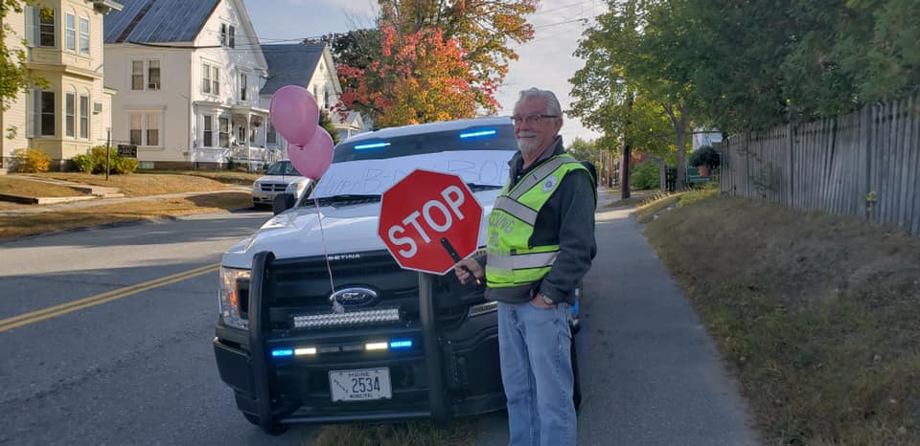Civilian Bob Hallman, Crossing Guard  Benefits  Salary & Benefits  - Base salary for new officers starting at $41,809 and top out at $51,400.  - Officers with experience may be offered lateral transfers.  - Education incentives & tuition reimbursement.  - Fitness & specialty incentives.  - Annual clothing allowance.  - Medical Health Coverage.  - Paid vacation and sick leave.  - Excellent retirement options including MPERS 20 years, no age retirement plan with COLA and/or ICMA 457 Deferred Compensation plan.  Sergeant Brandon Sholan  