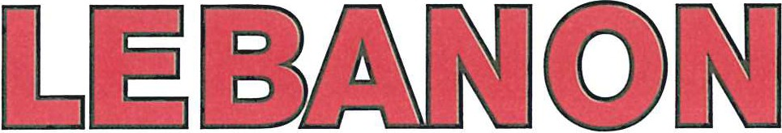

735 Cumberland Street Lebanon, PA 17042
NAME:

DATE OF BIRTH:

SOCIAL SECURITY NO.

I request and authorize you to release to the Lebanon Bureau of Fire Department and/or the Lebanon City Police Department any and all information that you may have concerning my employment record, school record, military record, criminal convictions, reputation and financial and credit status. Please include any and all records and reports, including information of a confidential or privileged nature. This information is to be used to assist the Lebanon Bureau of Fire Department and/or the Lebanon City Police Department in determining my qualifications and fitness for the position I am seeking with the Lebanon City Bureau of Fire Department.

I hereby release you, your organization or others from liability or damage which may result from furnishing the above requested information.

I certify that I have read and fully understand the foregoing statements.

Signature Date

AFFADAVIT

State of Pennsylvania
County of Lebanon

Before me personally appeared the said ______________ who says that he/she executed the above instrument of his/her own free will and accord, with full knowledge of the purpose therefore.

Sworn and subscribed in my presence this _______ day of _______.

Notary Public My Commission expires:
(717) 639-2800

Sherry L. Capello
Mayor

Aaron Sweitzer
Deputy Fire Chief

Union Steam Fire Engine
& Hose Co. No. 1

Perseverance Fire Co.

Lebanon Hook & Ladder Co. No. 1

Liberty Steam Fire Engine
& Hose Co. No. 3 Rescue Hose Co. No. 4
Goodwill Fire Engine
& Hose Co. No. 5

Chemical Engine &
Insurance Patrol Co. No. 1 Washington Fire Co. No. 8 Independent Fire Co.
Lebanon City Fire Police L-1952, I.A.F.F.
FIRE DEPARTMENT
PERSONAL INQUIRY WAIVER FORM

