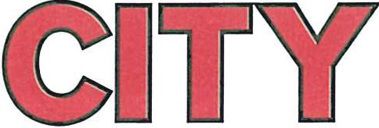

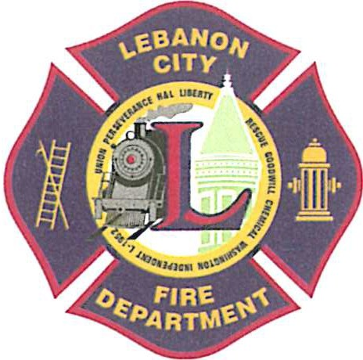
735 Cumberland Street Lebanon, PA 17042
In consideration of the granting of my request to be permitted upon this property, or jurisdiction of the Lebanon City Bureau of Fire, Lebanon Campus of Harrisburg Area Community College, and/or Lebanon County Commissioners in the Commonwealth of Pennsylvania under the control and supervision of the Fire Commissioner, I do waive all rights and claims and release and exempt the members, employees, and agents of the aforementioned agency from any and all claims for injuries, accidents, sickness, death and damages sustained, whether to my person or to my property, which may arise by reason of my presence upon the property or in any building or jurisdiction of the Lebanon City Bureau of Fire, Lebanon Campus of Harrisburg Area Community College and/or Lebanon County Commissioners or any or all members, employees or agents of the aforementioned agency whether such members are acting in their official capacity or in any individual capacity or within or without the scope of their employment.

I hereby assume the risk of all dangerous conditions in or about the properties of the Lebanon City Bureau of Fire, Lebanon Campus of Harrisburg Area Community College and/or the Lebanon County Commissioners which dangerous conditions I realize can, may and do exist, and therefore waive notice of existence of any such dangerous conditions.

At the signing of this waiver I represent that I am of lawful age and legally competent to execute the same. Before signing it, I have informed myself of its content and execute it with full knowledge and understanding thereof.

Signature Date

AFFADAVIT

State of Pennsylvania
County of Lebanon

Before me personally appeared the said ___________ who says that he/she executed the above instrument of his/her own free will and accord, with full knowledge of the purpose therefore.

Sworn and subscribed in my presence this _______ day of _______

Notary Public My Commission expires:
(717) 639-2800

Sherry L. Capello
Mayor

Aaron. Sweitzer
Deputy Fire Chief

Union Steam Fire Engine
& Hose Co. No. 1

Perseverance Fire Co.

Lebanon Hook & Ladder Co. No. 1

Liberty Steam Fire Engine
& Hose Co. No. 3 Rescue Hose Co. No. 4
Goodwill Fire Engine
& Hose Co. No. 5

Chemical Engine &
Insurance Patrol Co. No. 1 Washington Fire Co. No. 8 Independent Fire Co.
Lebanon City Fire Police L-1952, I.A.F.F.
FIRE DEPARTMENT
WAIVER

