CROMWELL POLICE
DEPARTMENT

Denise Lamontagne
Chief of Police
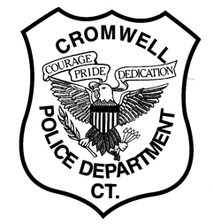
MINIMUM QUALIFICATIONS FOR POSITION OF POLICE OFFICER
TOWN OF CROMWELL, CT:

- MUST BE AT LEAST 20 YEARS OF AGE AT TIME OF TESTING AND 21 YEARS OLD AT TIME OF APPOINTMENT.

- MUST POSSESS AT LEAST A HIGH SCHOOL DIPLOMA OR G.E.D. EQUIVALENT.

- MUST PASS WRITTEN EXAMINATION.

- THE SUCCESSFUL PERCENTAGE OF APPLICANTS WILL BE REQUIRED TO PASS EACH PHASE OF THE FOLLOWING:

A. PHYSICAL AGILITY FOR NON-CERTIFIED OFFICERS
B. ORAL EXAMINATION
C. BACKGROUND EXAMINATION

- MUST PASS DRUG SCREENING URINALYSIS.

- MUST SUBMIT TO POLYGRAPH EXAMINATION.

- MUST SUBMIT TO PSYCHOLOGICAL EXAMINATION.

- MUST SUBMIT TO MEDICAL PHYSICAL EXAMINATION THAT MAY INCLUDE STRESS TEST.

- VISION: 20/50 CORRECTABLE TO 20/20.

- MUST BE NON-SMOKER.

- MUST POSSESS CONNECTICUT DRIVER’S LICENSE WITH GOOD DRIVING HISTORY.

Denise Lamontagne
Chief of Police

